**Naive Bayes Classifier**

=== Stratified cross-validation ===

=== Summary ===

Correctly Classified Instances 373 44.0898 %

Incorrectly Classified Instances 473 55.9102 %

Kappa statistic 0.2604

Mean absolute error 0.2824

Root mean squared error 0.4638

Relative absolute error 75.3486 %

Root relative squared error 107.1418 %

Total Number of Instances 846

=== Detailed Accuracy By Class ===

TP Rate FP Rate Precision Recall F-Measure MCC ROC Area PRC Area Class

0.429 0.186 0.435 0.429 0.432 0.244 0.700 0.433 opel

0.332 0.130 0.468 0.332 0.388 0.228 0.698 0.452 saab

0.138 0.019 0.714 0.138 0.231 0.239 0.842 0.616 bus

0.905 0.403 0.408 0.905 0.563 0.425 0.831 0.552 van

Weighted Avg. 0.441 0.180 0.509 0.441 0.400 0.281 0.767 0.513

**=== Confusion Matrix ===**

a b c d <-- classified as

91 55 3 63 | a = opel

78 72 1 66 | b = saab

34 22 30 132 | c = bus

6 5 8 180 | d = van

**LMT:**

=== Summary ===

Correctly Classified Instances 704 83.2151 %

Incorrectly Classified Instances 142 16.7849 %

Kappa statistic 0.7761

Mean absolute error 0.1049

Root mean squared error 0.247

Relative absolute error 27.9854 %

Root relative squared error 57.0531 %

Total Number of Instances 846

=== Detailed Accuracy By Class ===

TP Rate FP Rate Precision Recall F-Measure MCC ROC Area PRC Area Class

0.689 0.099 0.699 0.689 0.694 0.592 0.908 0.749 opel

0.705 0.092 0.725 0.705 0.715 0.619 0.919 0.774 saab

0.986 0.014 0.960 0.986 0.973 0.963 0.996 0.983 bus

0.955 0.019 0.941 0.955 0.948 0.931 0.996 0.985 van

Weighted Avg. 0.832 0.057 0.830 0.832 0.831 0.774 0.954 0.871

**=== Confusion Matrix ===**

a b c d <-- classified as

146 55 4 7 | a = opel

60 153 1 3 | b = saab

1 0 215 2 | c = bus

2 3 4 190 | d = van

**KNN(IBK):**

using 170 nearest neighbour(s) for classification

=== Summary ===

Correctly Classified Instances 361 42.6714 %

Incorrectly Classified Instances 485 57.3286 %

Kappa statistic 0.2363

Mean absolute error 0.3362

Root mean squared error 0.4057

Relative absolute error 89.6859 %

Root relative squared error 93.7014 %

Total Number of Instances 846

=== Detailed Accuracy By Class ===

TP Rate FP Rate Precision Recall F-Measure MCC ROC Area PRC Area Class

0.344 0.178 0.392 0.344 0.367 0.174 0.702 0.379 opel

0.198 0.099 0.410 0.198 0.267 0.132 0.720 0.445 saab

0.564 0.291 0.402 0.564 0.469 0.248 0.696 0.409 bus

0.613 0.196 0.490 0.613 0.545 0.388 0.882 0.650 van

Weighted Avg. 0.427 0.191 0.422 0.427 0.410 0.233 0.748 0.467

**=== Confusion Matrix ===**

a b c d <-- classified as

73 45 52 42 | a = opel

77 43 55 42 | b = saab

35 17 123 43 | c = bus

1 0 76 122 | d = van

**Logistic:**

=== Stratified cross-validation ===

=== Summary ===

Correctly Classified Instances 664 78.487 %

Incorrectly Classified Instances 182 21.513 %

Kappa statistic 0.7131

Mean absolute error 0.1229

Root mean squared error 0.2704

Relative absolute error 32.7782 %

Root relative squared error 62.4615 %

Total Number of Instances 846

=== Detailed Accuracy By Class ===

TP Rate FP Rate Precision Recall F-Measure MCC ROC Area PRC Area Class

0.627 0.128 0.621 0.627 0.624 0.498 0.881 0.668 opel

0.631 0.116 0.652 0.631 0.642 0.521 0.895 0.717 saab

0.936 0.019 0.944 0.936 0.940 0.919 0.976 0.941 bus

0.955 0.025 0.922 0.955 0.938 0.919 0.982 0.944 van

Weighted Avg. 0.785 0.073 0.783 0.785 0.784 0.712 0.933 0.816

**=== Confusion Matrix ===**

a b c d <-- classified as

133 66 4 9 | a = opel

71 137 5 4 | b = saab

7 4 204 3 | c = bus

3 3 3 190 | d = van

**J48:**

=== Summary ===

Correctly Classified Instances 615 72.695 %

Incorrectly Classified Instances 231 27.305 %

Kappa statistic 0.6358

Mean absolute error 0.1428

Root mean squared error 0.3365

Relative absolute error 38.1052 %

Root relative squared error 77.7246 %

Total Number of Instances 846

=== Detailed Accuracy By Class ===

TP Rate FP Rate Precision Recall F-Measure MCC ROC Area PRC Area Class

0.514 0.125 0.580 0.514 0.545 0.406 0.765 0.526 opel

0.548 0.161 0.541 0.548 0.545 0.386 0.737 0.475 saab

0.950 0.038 0.896 0.950 0.922 0.895 0.961 0.890 bus

0.905 0.042 0.870 0.905 0.887 0.851 0.938 0.794 van

Weighted Avg. 0.727 0.092 0.719 0.727 0.722 0.632 0.849 0.670

**=== Confusion Matrix ===**

a b c d <-- classified as

109 87 7 9 | a = opel

69 119 14 15 | b = saab

2 6 207 3 | c = bus

8 8 3 180 | d = van

|  |  |  |  |  |  |  |  |
| --- | --- | --- | --- | --- | --- | --- | --- |
| **LMT** | | Predictive Class | | | |  |  |
| opel | saab | bus | van | TP Rate | FP Rate |
| Actual Class | opel | 146 | 55 | 4 | 7 | 0.689 | 0.099 |
| saab | 60 | 153 | 1 | 3 | 0.705 | 0.092 |
| bus | 1 | 0 | 215 | 2 | 0.986 | 0.014 |
| van | 2 | 3 | 4 | 190 | 0.955 | 0.019 |
|  |  |  |  |  |  |  |  |

|  |  |  |  |  |  |  |  |
| --- | --- | --- | --- | --- | --- | --- | --- |
| **Naive** | | Predictive Class | | | |  |  |
| opel | saab | bus | van | TP Rate | FP Rate |
| Actual Class | opel | 91 | 55 | 3 | 63 | 0.429 | 0.186 |
| saab | 78 | 72 | 1 | 66 | 0.332 | 0.130 |
| bus | 34 | 22 | 30 | 132 | 0.138 | 0.019 |
| van | 6 | 5 | 8 | 180 | 0.905 | 0.403 |

|  |  |  |  |  |  |  |  |
| --- | --- | --- | --- | --- | --- | --- | --- |
| **IBK(170)** | | Predictive Class | | | |  |  |
| opel | saab | bus | van | TP Rate | FP Rate |
| Actual Class | opel | 73 | 45 | 52 | 42 | 0.344 | 0.178 |
| saab | 77 | 43 | 55 | 42 | 0.198 | 0.099 |
| bus | 35 | 17 | 123 | 43 | 0.564 | 0.291 |
| van | 1 | 0 | 76 | 122 | 0.613 | 0.196 |
|  |  |  |  |  |  |  |  |

|  |  |  |  |  |  |  |  |
| --- | --- | --- | --- | --- | --- | --- | --- |
| **Logistic** | | predictive Class | | | |  |  |
| opel | saab | bus | van | TP Rate | FP Rate |
| Actual Class | opel | 133 | 66 | 4 | 9 | 0.627 | 0.128 |
| saab | 71 | 137 | 5 | 4 | 0.631 | 0.116 |
| bus | 7 | 4 | 204 | 3 | 0.936 | 0.019 |
| van | 3 | 3 | 3 | 190 | 0.955 | 0.025 |

|  |  |  |  |  |  |  |  |
| --- | --- | --- | --- | --- | --- | --- | --- |
| **J48** | | predictive Class | | | |  |  |
| opel | saab | bus | van | TP Rate | FP Rate |
| Actual Class | opel | 109 | 87 | 7 | 9 | 0.514 | 0.125 |
| saab | 69 | 119 | 14 | 15 | 0.548 | 0.161 |
| bus | 2 | 6 | 207 | 3 | 0.950 | 0.038 |
| van | 8 | 8 | 3 | 180 | 0.905 | 0.042 |

**Identifying Opel as positive interest:**

|  |  |  |  |  |
| --- | --- | --- | --- | --- |
|  |  | TP Rate | | FP rate |
| LMT | | | 0.689 | 0.099 |
| Naive | | | 0.429 | 0.186 |
| KNN | | | 0.344 | 0.178 |
| Logistic | | | 0.627 | 0.128 |
| J48 | | | 0.514 | 0.125 |

**ROC Graph:**

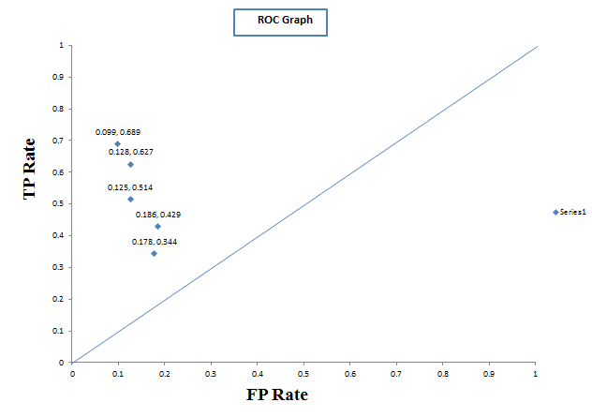**For classifying opel** : As positive interest i have to look for a classifier that maximizes true positive rate than othar calssifiers and minimizes false positive rate than other classifier. So from ROC we can see LMT is overall best in this case.

**Identifying Saab as positive interest:**

|  |  |  |  |  |
| --- | --- | --- | --- | --- |
|  |  | TP Rate | | FP rate |
| LMT | | | 0.705 | 0.092 |
| Naive | | | 0.332 | 0.130 |
| KNN | | | 0.198 | 0.099 |
| Logistic | | | 0.631 | 0.116 |
| J48 | | | 0.548 | 0.161 |

**ROC Graph:**

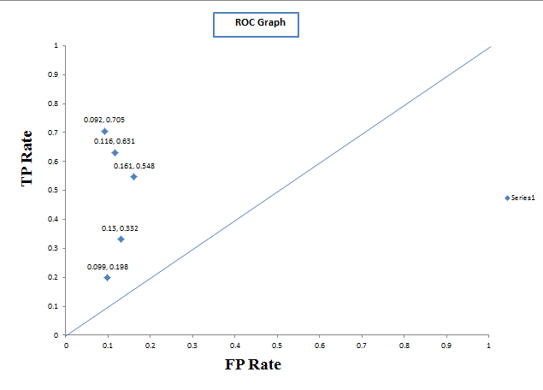

**For classifying saab:** As positive interest i have to look for a classifier that maximizes true positive rate than othar calssifiers and minimizes false positive rate than other classifier. So from ROC we can see LMT is overall best in this case.

**Identifying bus as positive interest:**

|  |  |  |  |  |
| --- | --- | --- | --- | --- |
|  |  | TP Rate | | FP rate |
| LMT | | | 0.986 | 0.014 |
| Naive | | | 0.138 | 0.019 |
| KNN | | | 0.564 | 0.291 |
| Logistic | | | 0.936 | 0.019 |
| J48 | | | 0.950 | 0.038 |

**ROC Graph:**

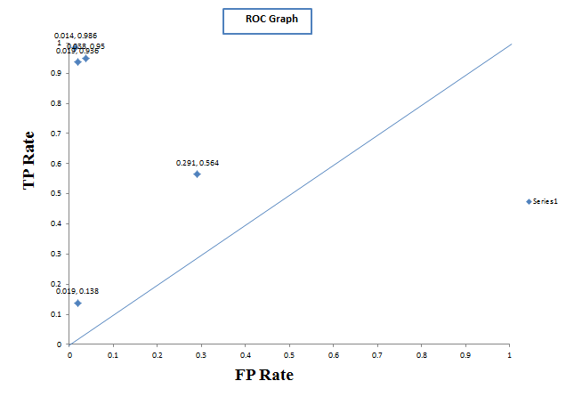

**For classifying bus**: As positive interest i have to look for a classifier that maximizes true positive rate than othar calssifiers and minimizes false positive rate than other classifier. So from ROC we can see LMT is overall best in this case.

**Identifying van as positive interest:**

|  |  |  |  |  |
| --- | --- | --- | --- | --- |
|  |  | TP Rate | | FP rate |
| LMT | | | 0.955 | 0.019 |
| Naive | | | 0.905 | 0.403 |
| KNN | | | 0.613 | 0.196 |
| Logistic | | | 0.955 | 0.025 |
| J48 | | | 0.905 | 0.042 |

**ROC Graph:**

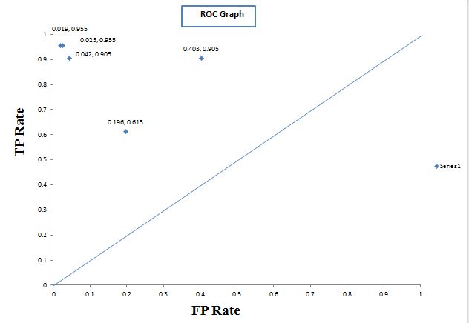

**For classifying van:** As positive interest i have to look for a classifier that maximizes true positive rate than othar calssifiers and minimizes false positive rate than other classifier. So from ROC we can see LMT is overall best in this case.